- Write an SQL query to print the first three characters of Country_name from the Country table.
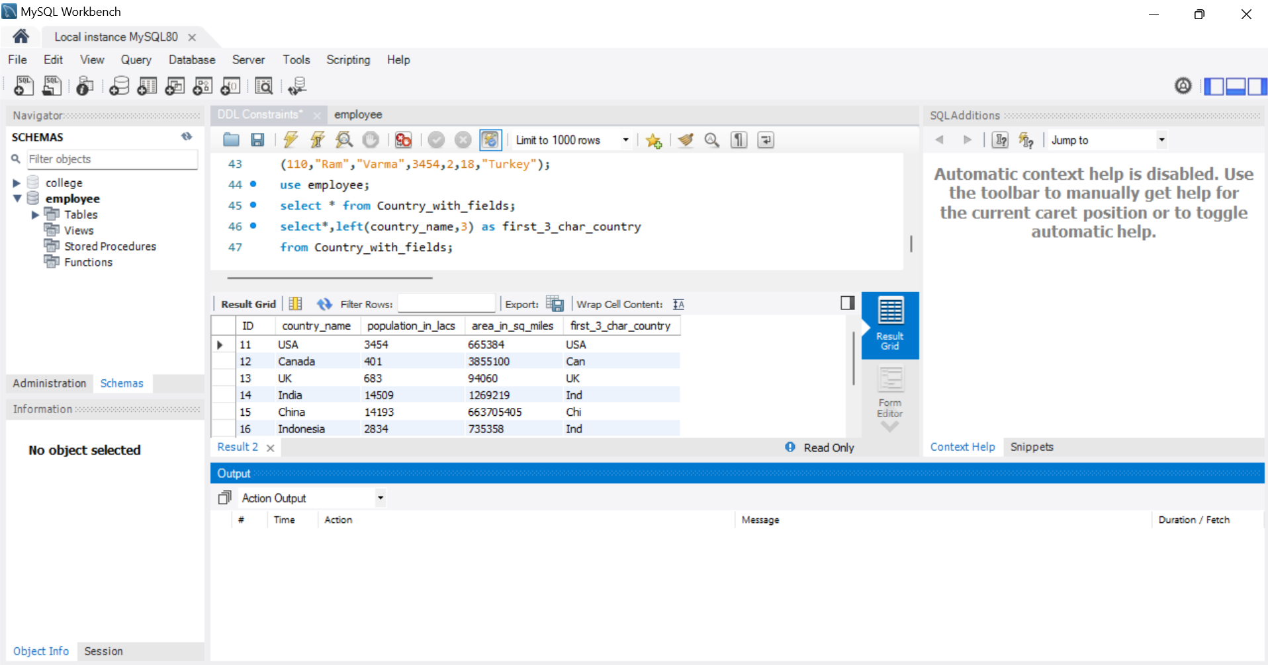
- Write an SQL query to concatenate first name and last name from Persons table.
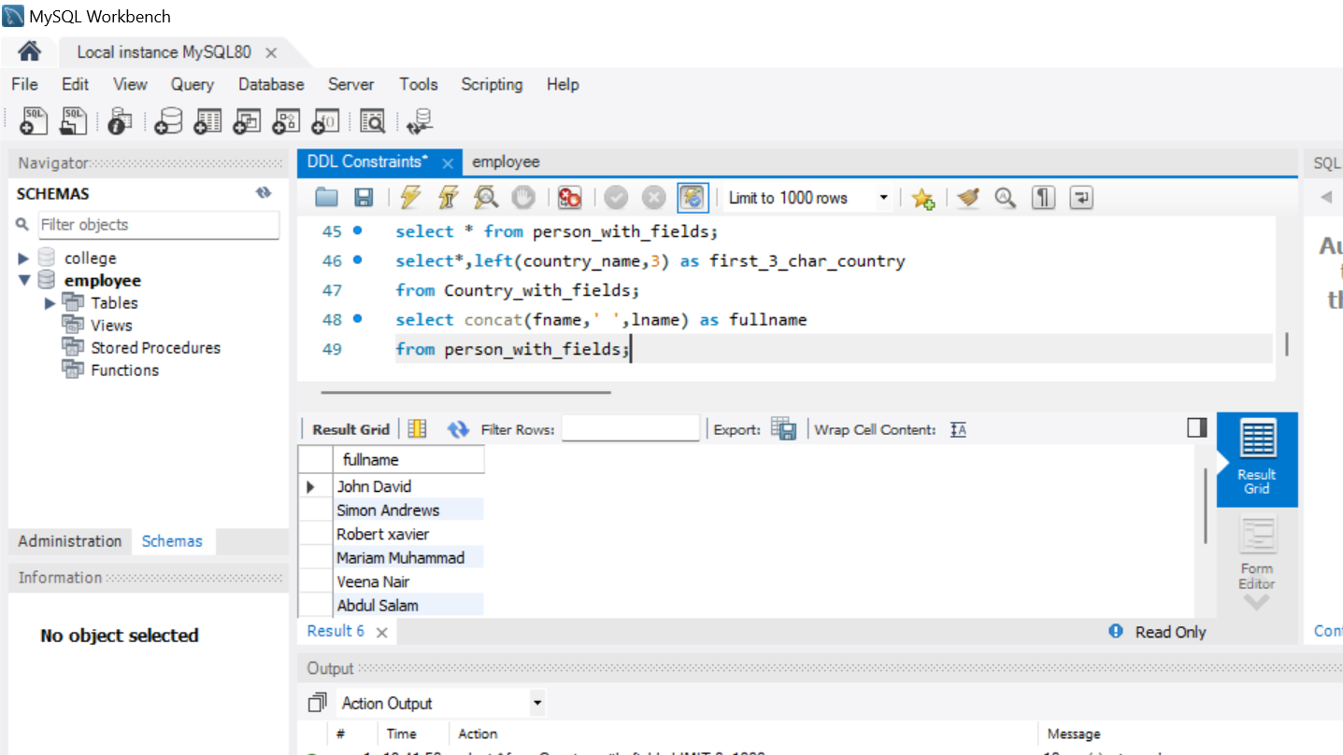
- Write an SQL query to count the number of unique country names from Persons table.
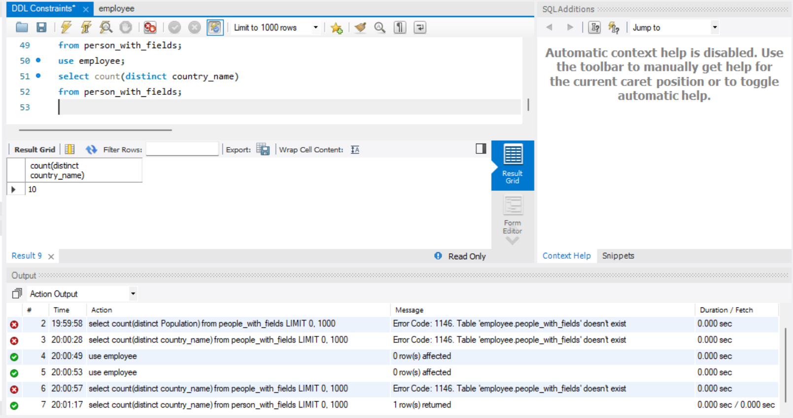
- Write a query to print the maximum population from the Country table.
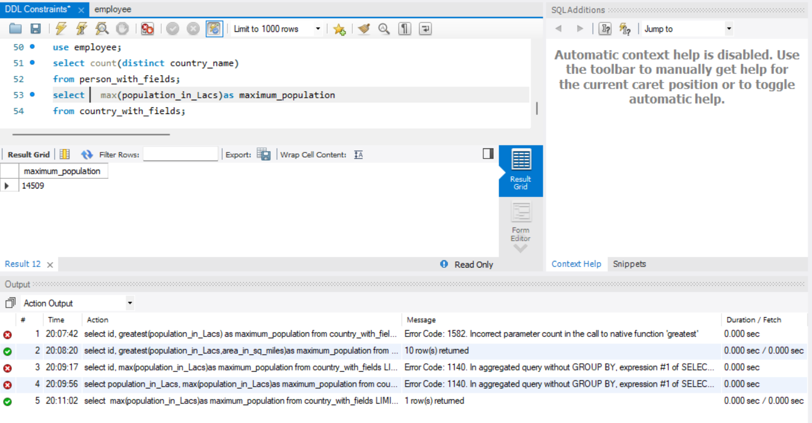
- Write a query to print the minimum population from Persons table
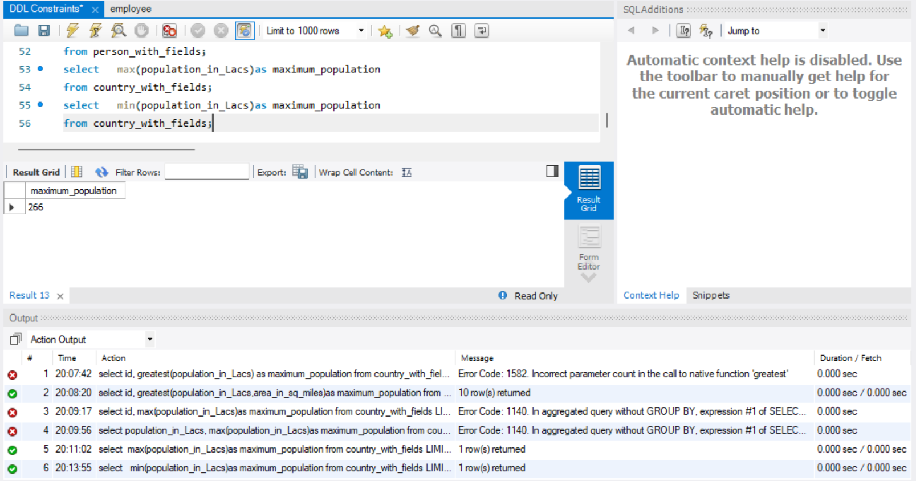
- Insert 2 new rows to the Persons table making the Lname NULL. Then write another query to
count Lname from Persons table
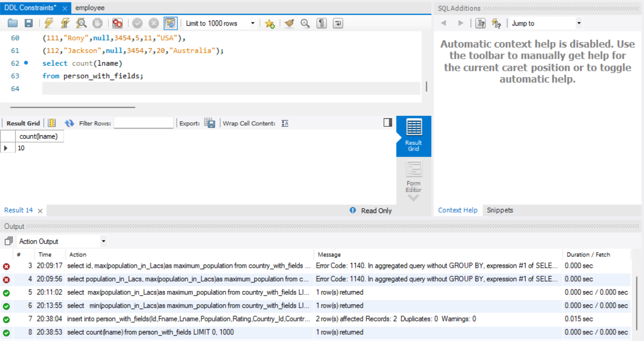
- Write a query to find the number of rows in the Persons table
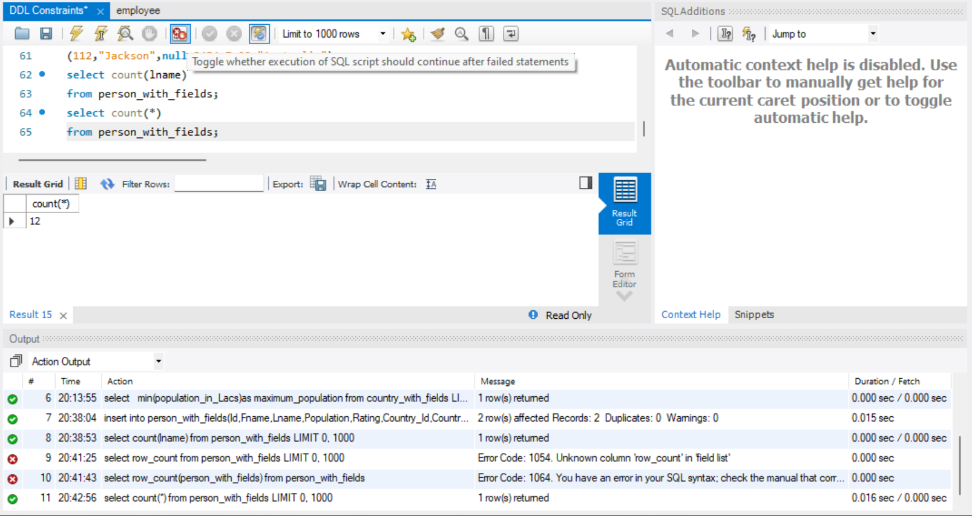
- Write an SQL query to show the population of the Country table for the first 3 rows.
(Hint: Use LIMIT)
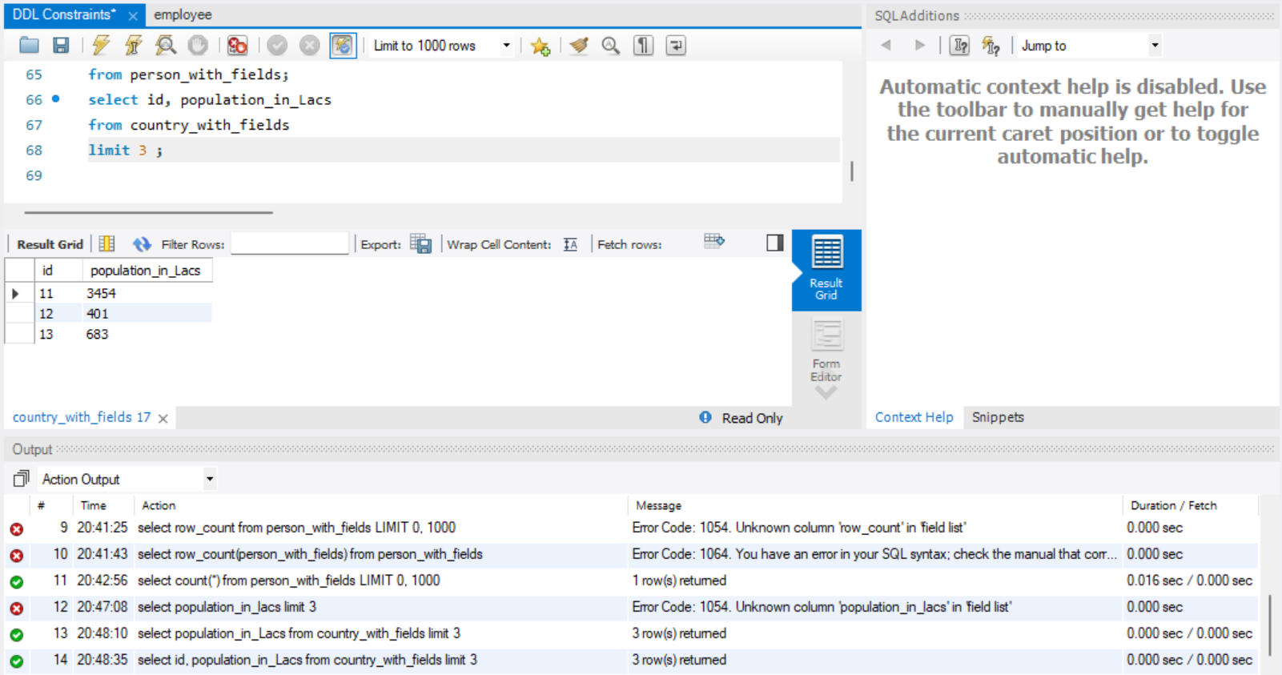
- Write a query to print 3 random rows of countries. (Hint: Use rand() function and LIMIT

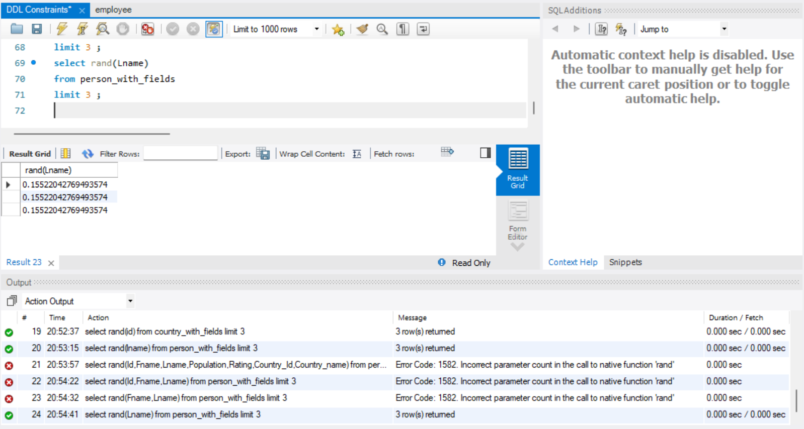
- List all persons ordered by their rating in descending order.
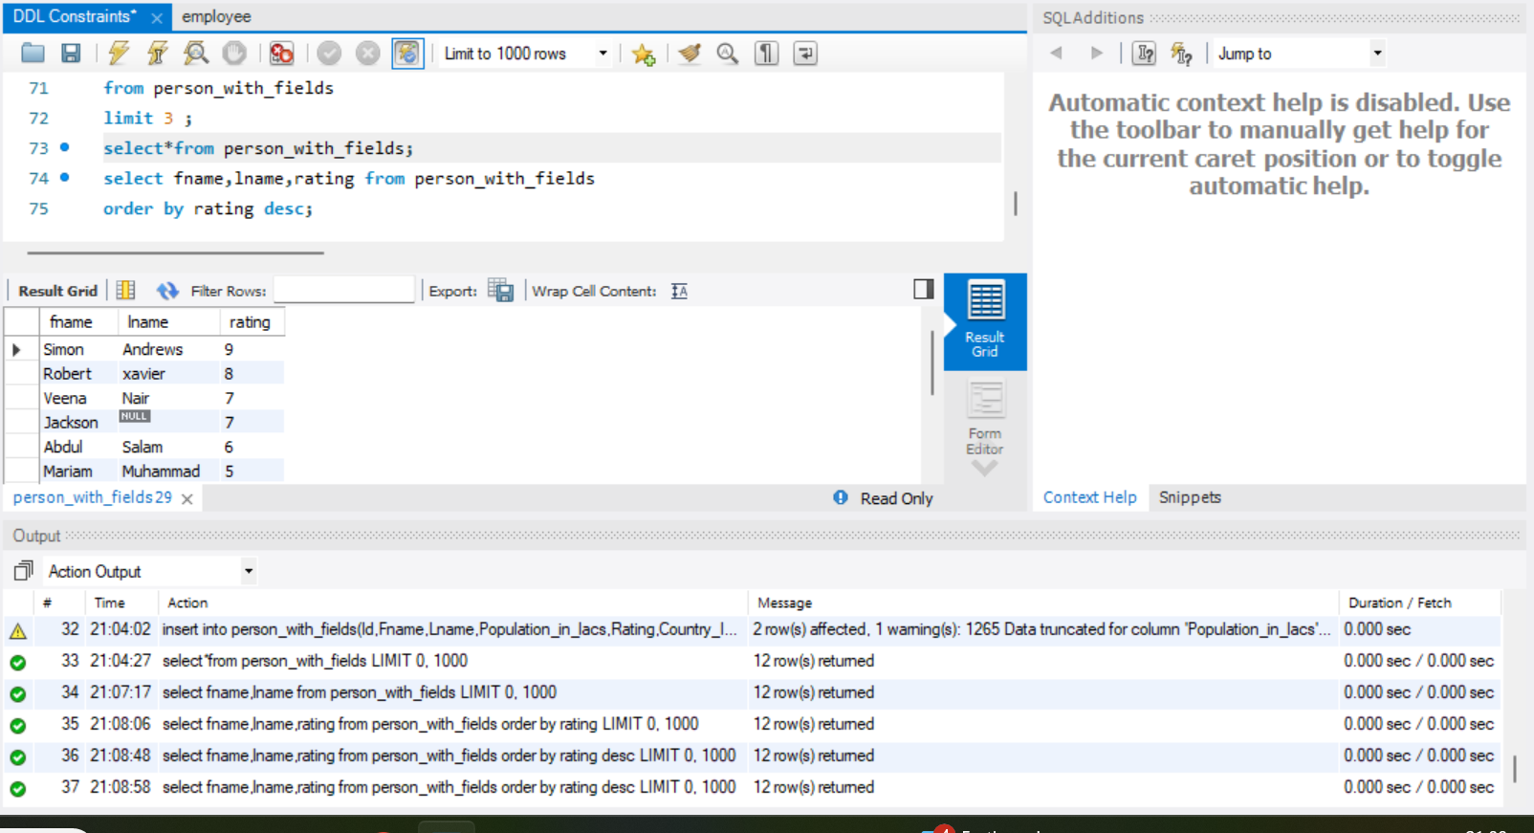
- Find the total population for each country in the Persons table.
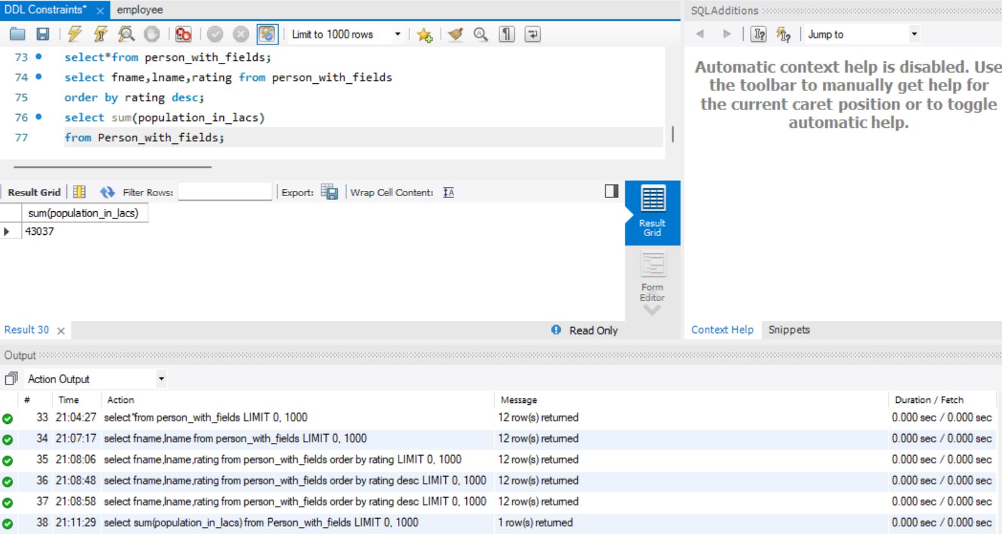
- Find countries in the Persons table with a total population greater than 50,000
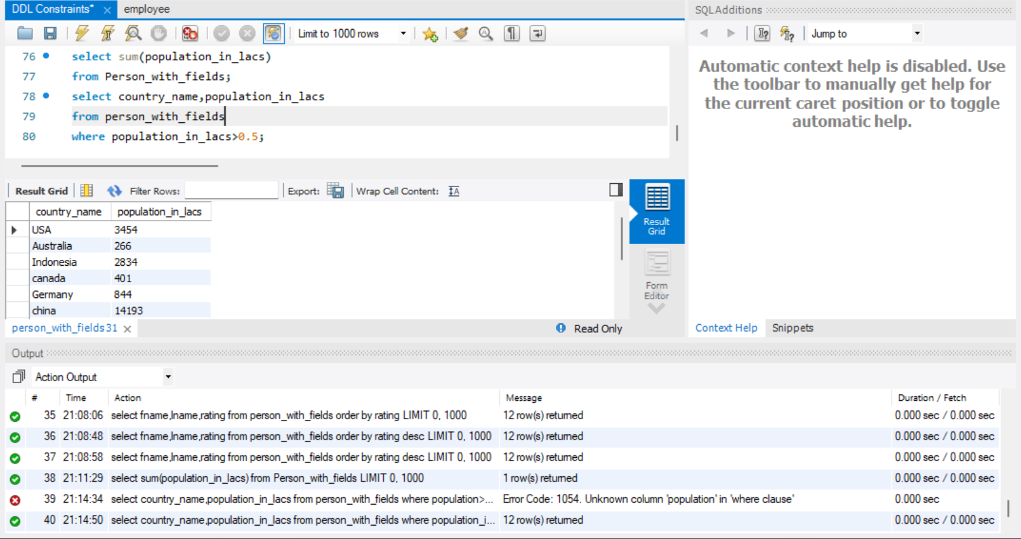
- List the total number of persons and average rating for each country, but only for countries with more than 2 persons, ordered by the average rating in ascending order.
